Chapter 6, Problem 58.

The current waveform in Fig. 6.80 flows through a 3-H inductor. Sketch the voltage across the inductor over the interval 0 < t < 6 s.

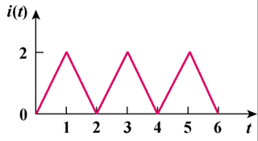

Figure 6.80
For Prob. 6.58.

